**AWS CodeCommit**

* **Short Description:** similar to git, seamlessly work with git commands
* **Free Tier:**

1,000 repositories per account; up to 25,000 [upon request](https://docs.aws.amazon.com/general/latest/gr/aws_service_limits.html)

50 GB-month of storage

10,000 Git requests/month

**AWS CodeBuild**

* **Short Description:** set up environment and test, if succeeded then create artifacts
* **Free Tier:** 100 build minutes of build.general1.small per month

**AWS CodeDeploy**

* **Short Description:** automates software deployments to a variety of compute services such as Amazon EC2, AWS Fargate, AWS Lambda, and your on-premises servers.
* **Free Tier:** no additional charge for code deployments to Amazon EC2, AWS Lambda or Amazon ECS through AWS CodeDeploy

**AWS CodePipeline**

* **Short Description:** automates the build, test, and deploy phases
* **Free Tier:** one free active pipeline each month

Application Link: <https://github.com/balajee-rm/aws/blob/main/Session%2014%20and%2015/demo.zip>

CodeCommit

Click on create repository

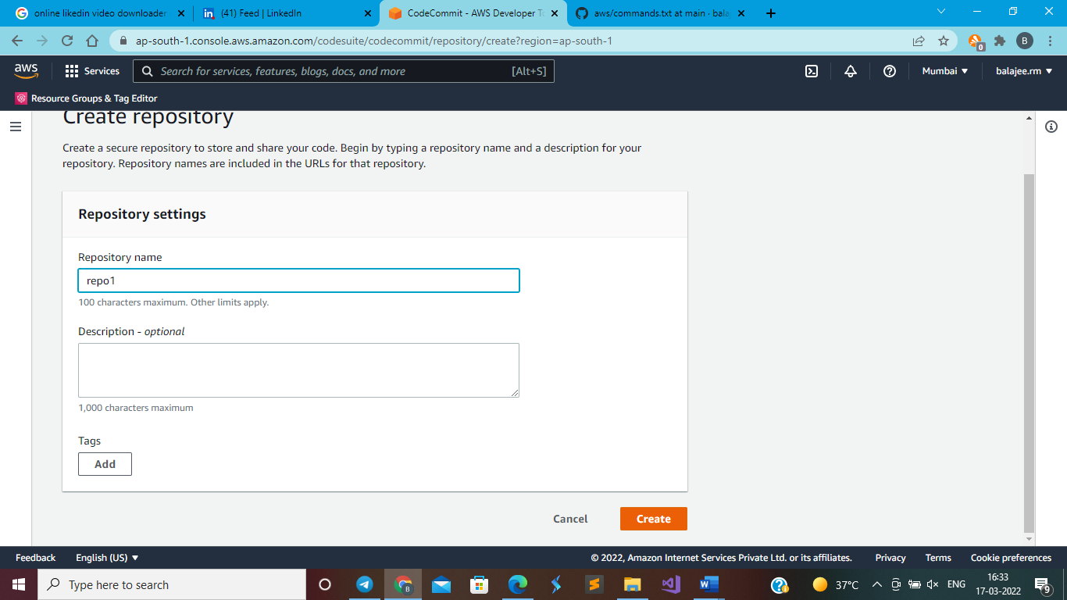

Clone on https url

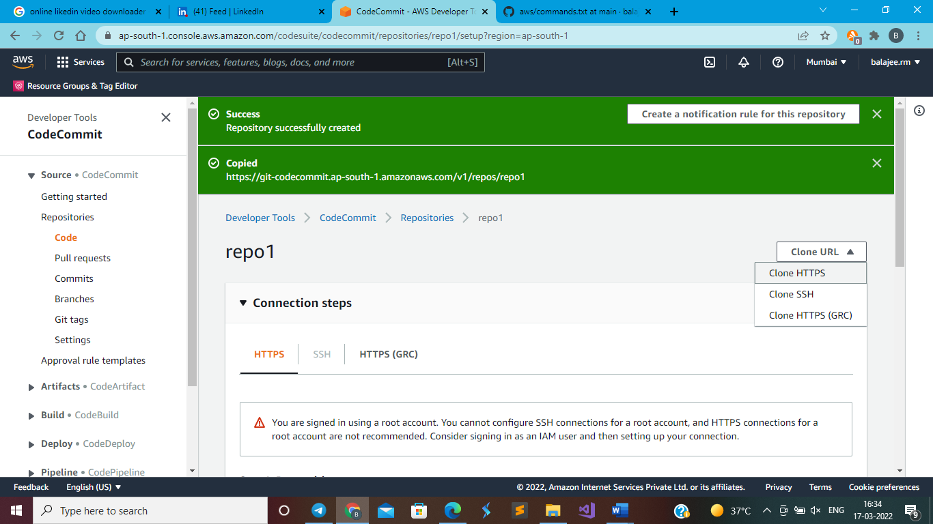

In your local system create folder app

Open cmd inside the folder (folder location)

git clone <http_url_copied_already>

**it will ask for the credentials, so follow below steps**

in cmd provide -> aws configure

now you have to provide secreat keys downloaded from “IAM user” security credentials tab inside IAM user (if you are not having IAM User, then create one)

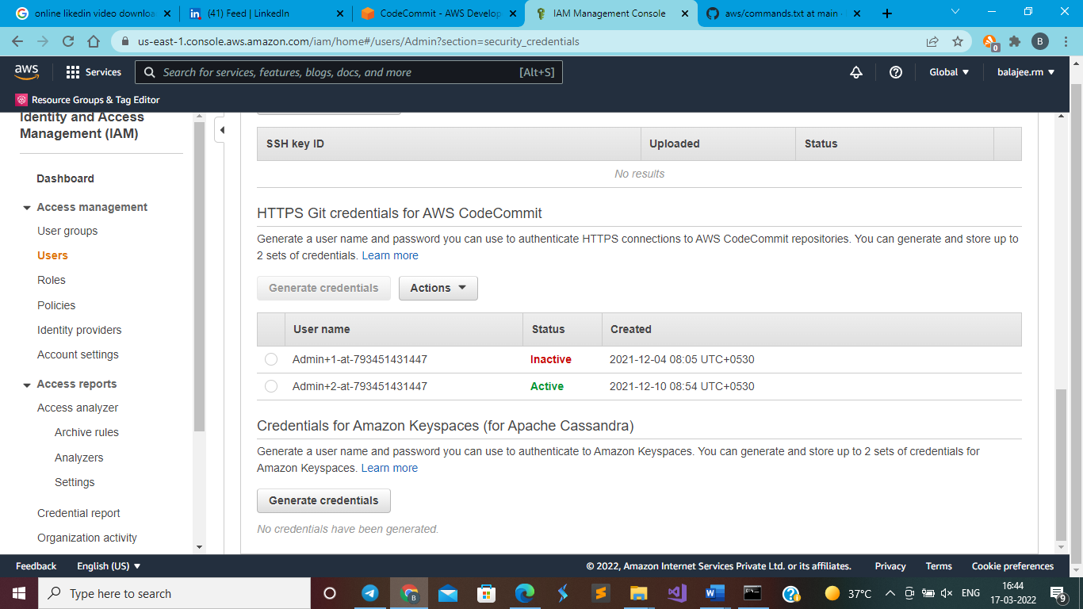

**After cloning successful**

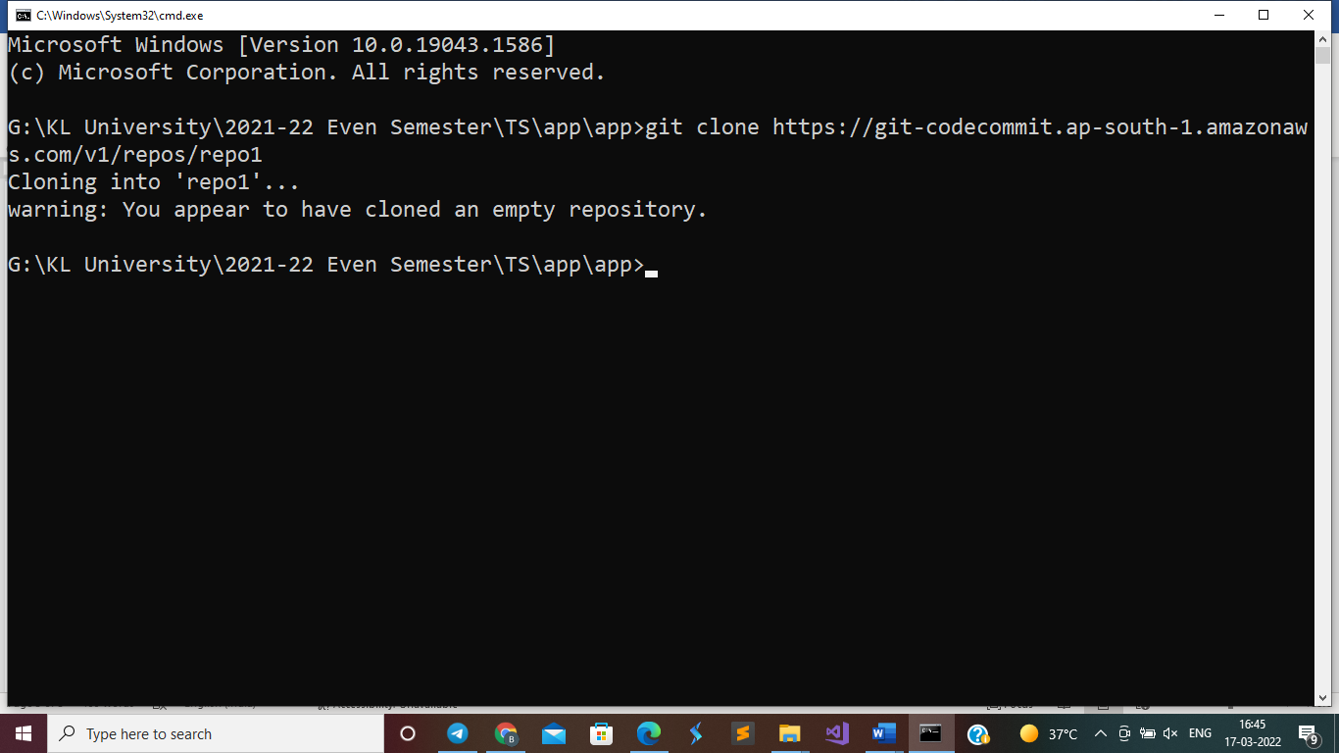

Extract the demo zip file inside app->repo1 directory and delete demo.zip

Cd repo1

Cmd - > git add .

Cmd -> git commit -m “fc”

Cmd -> git push

Now your codecommit have the files

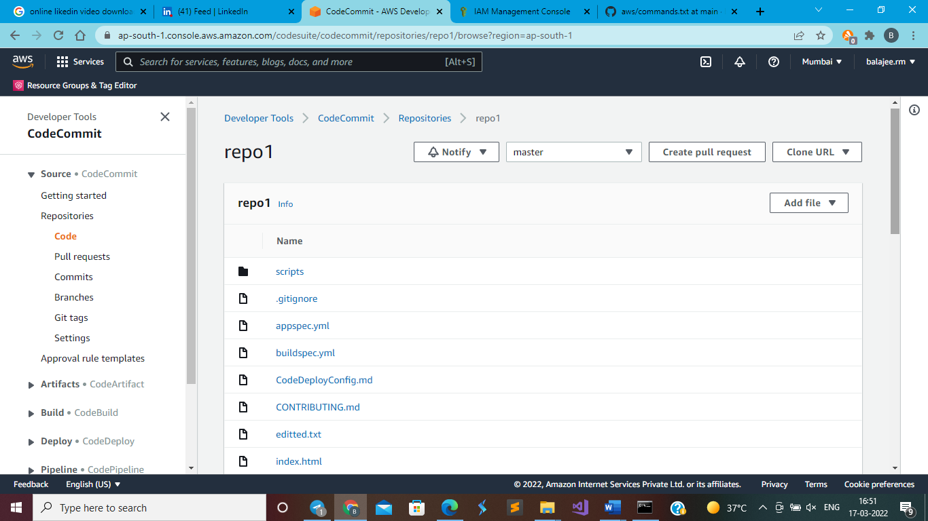

**Go to codebuild**

First create one bucket and have it ready

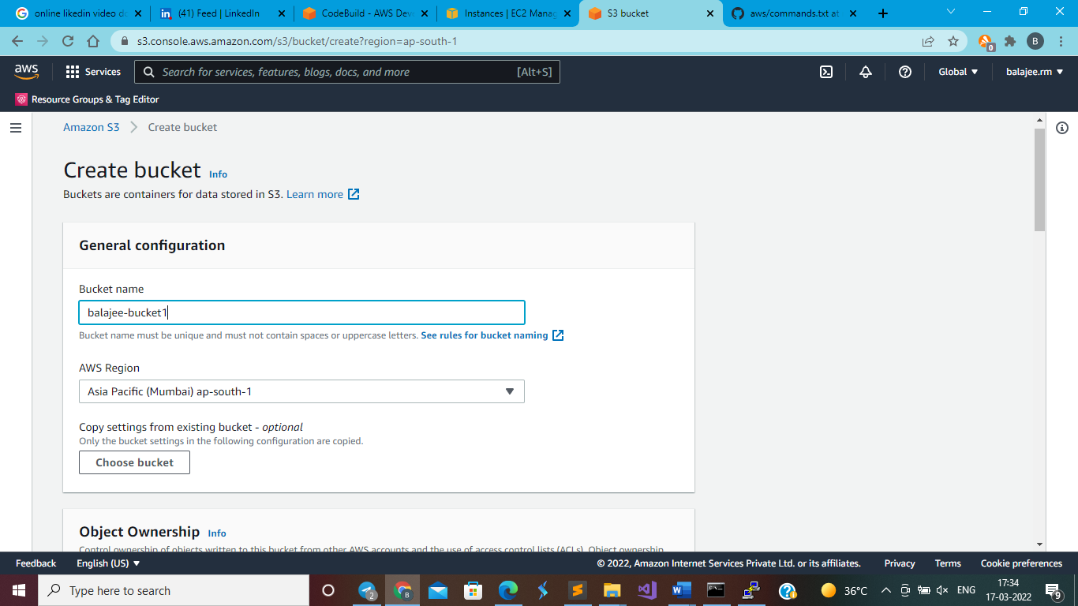

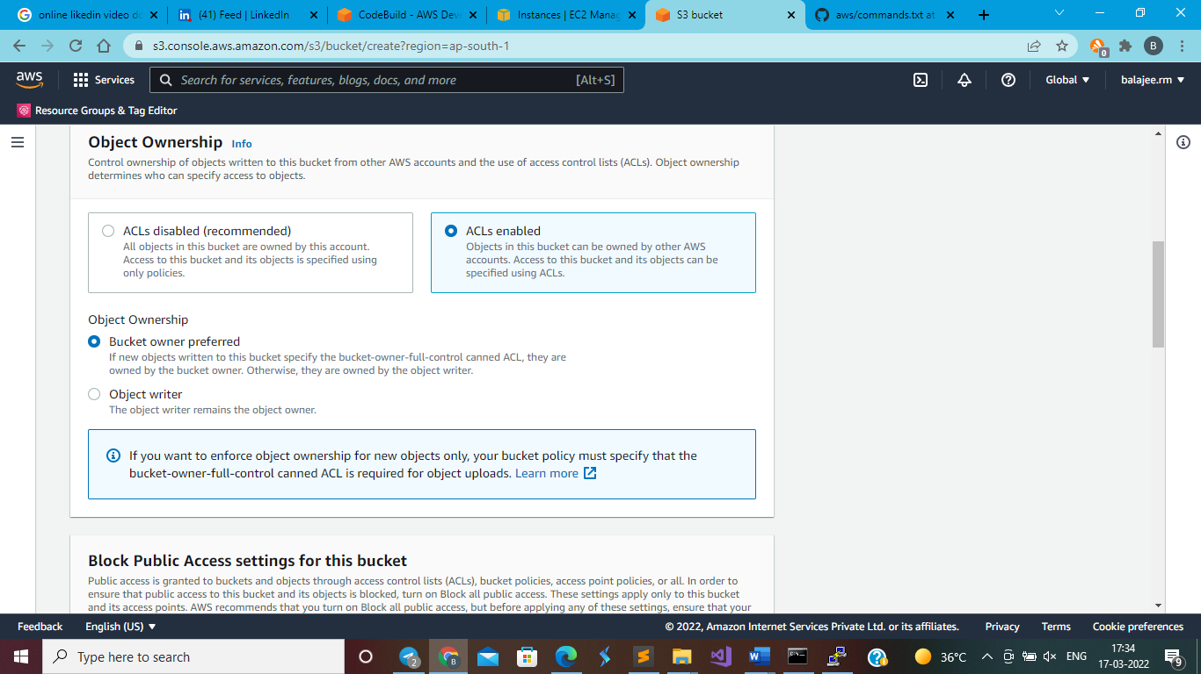

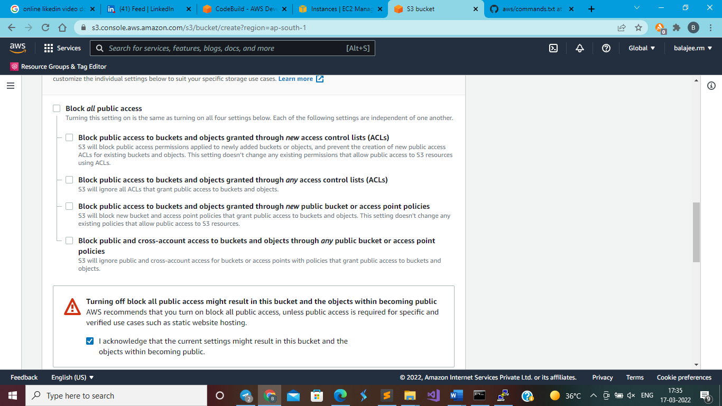

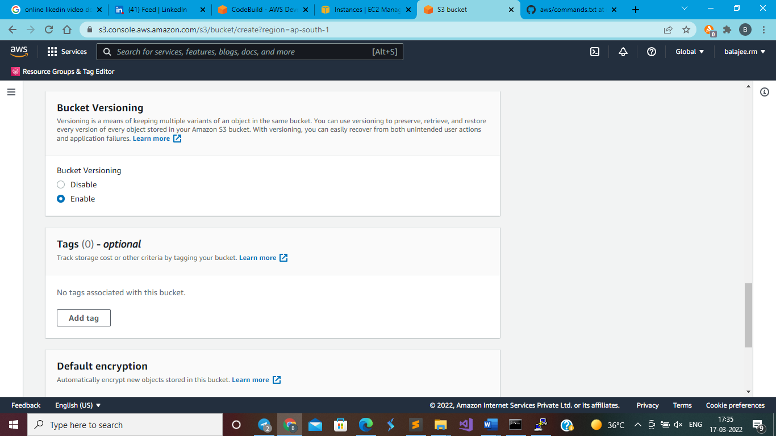

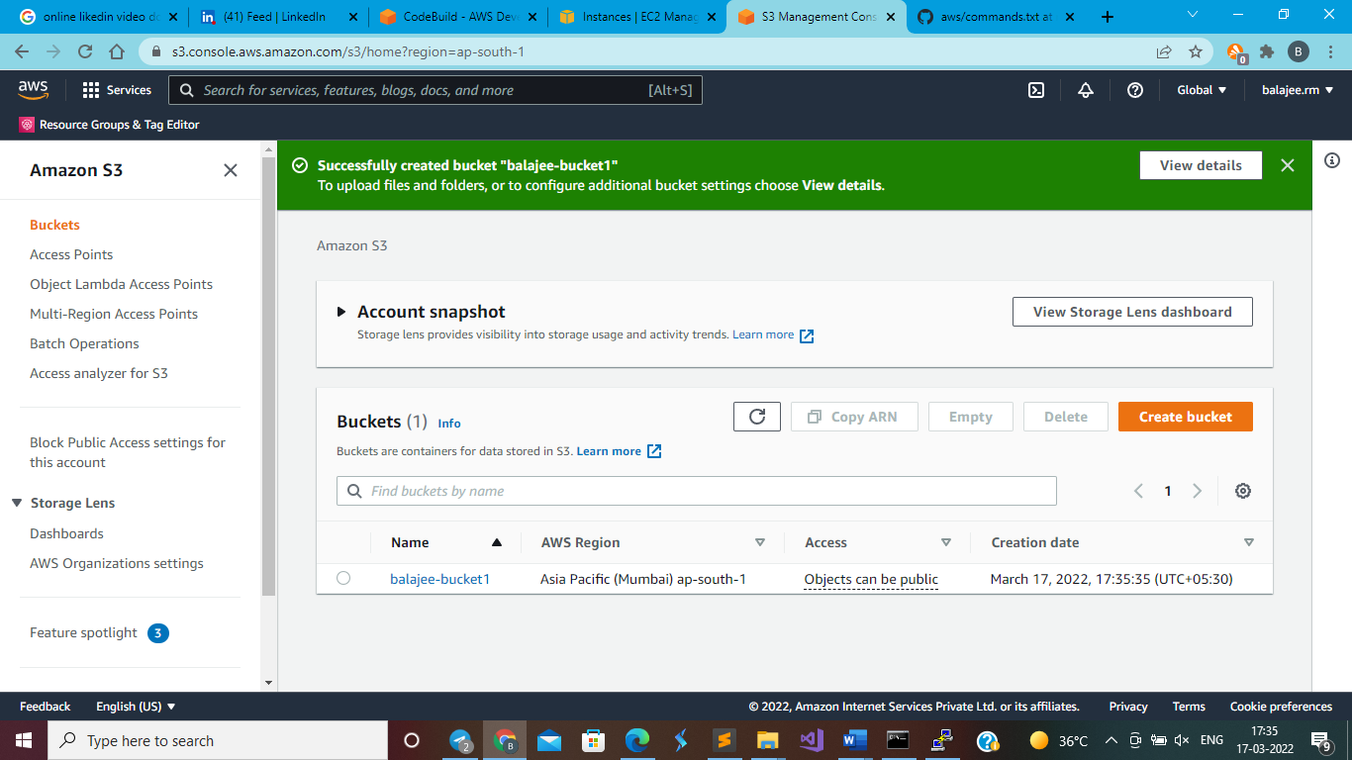

Go to code build

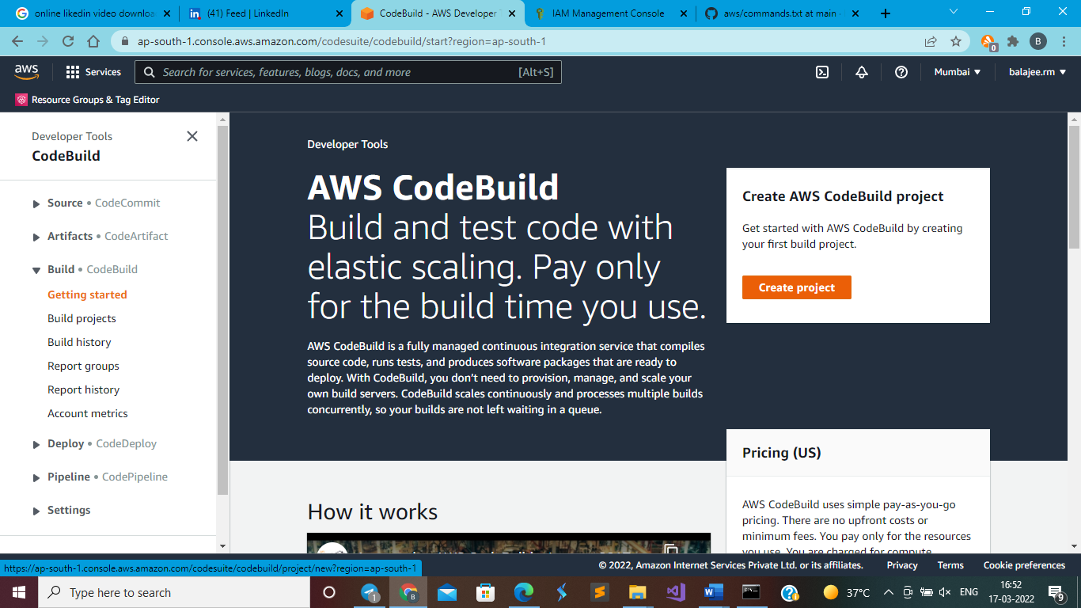

click on create project

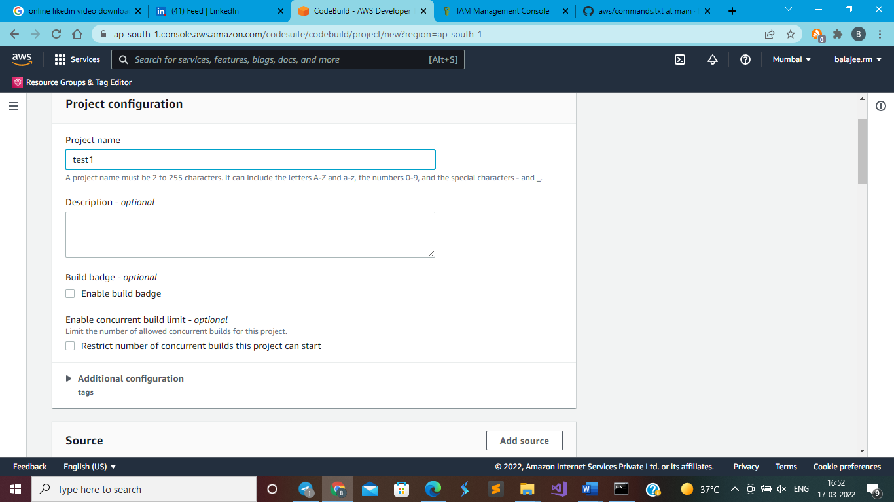

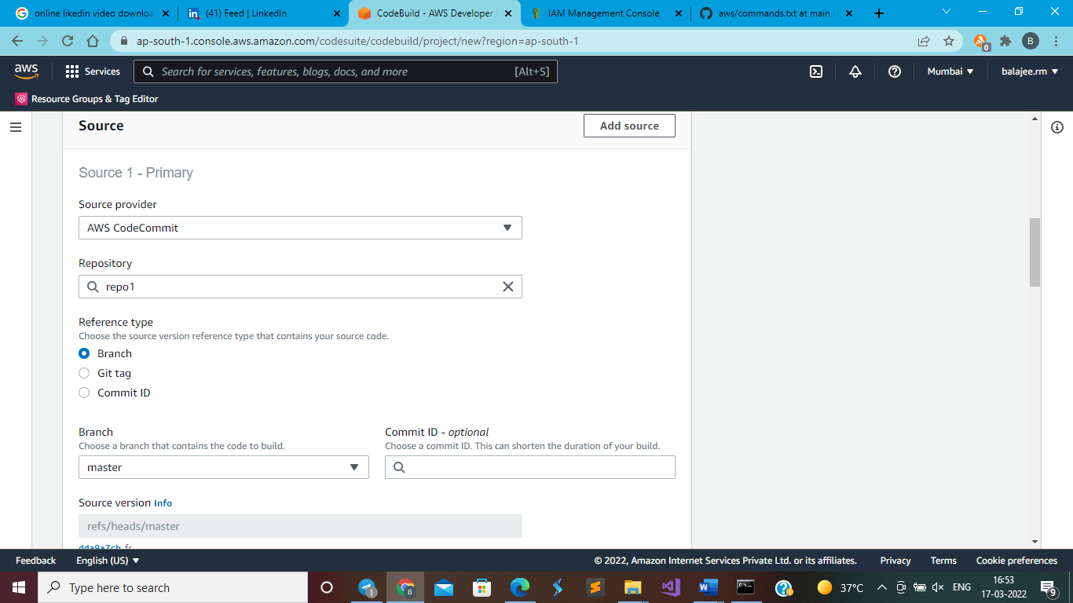

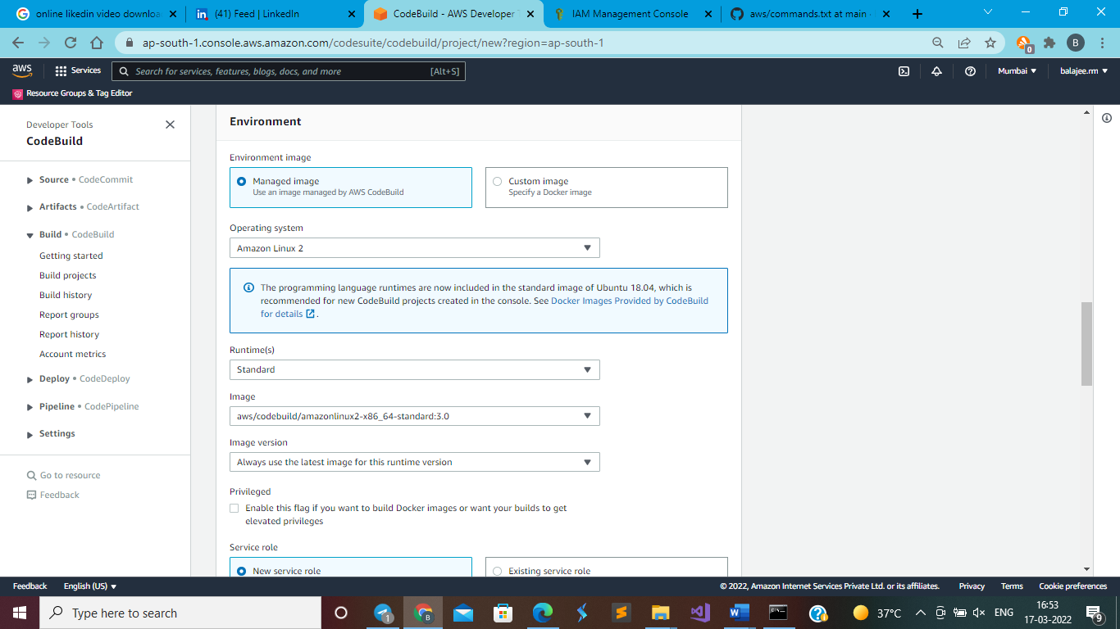

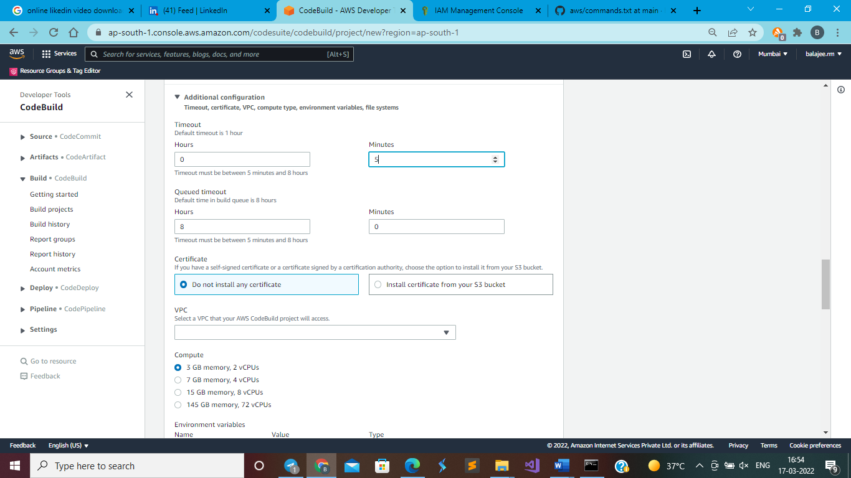

Only you have to choose 3gb one, which is free for 100 min of running

In artifact section

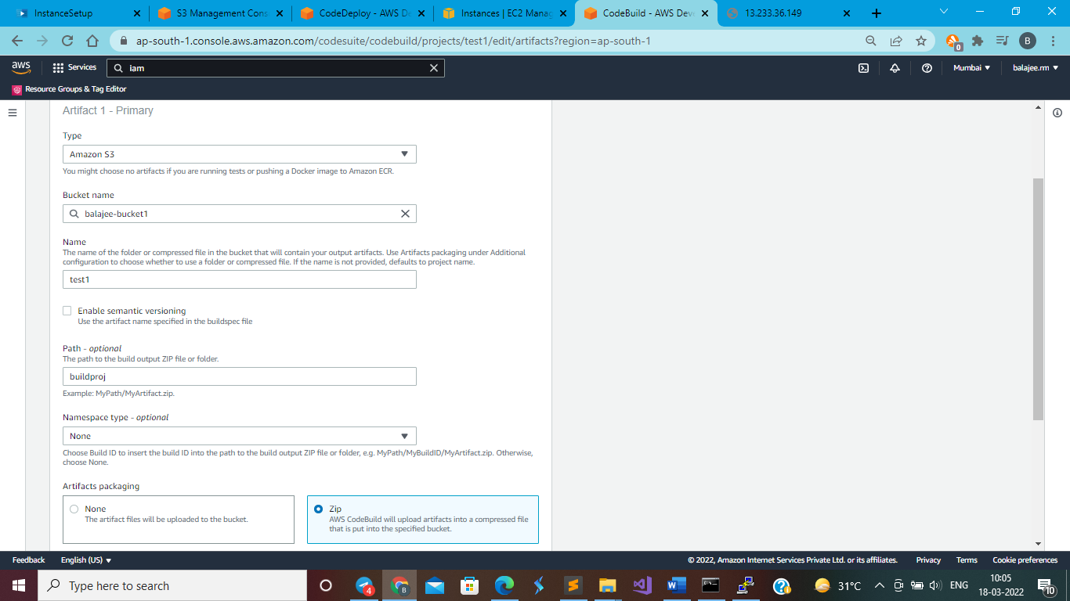

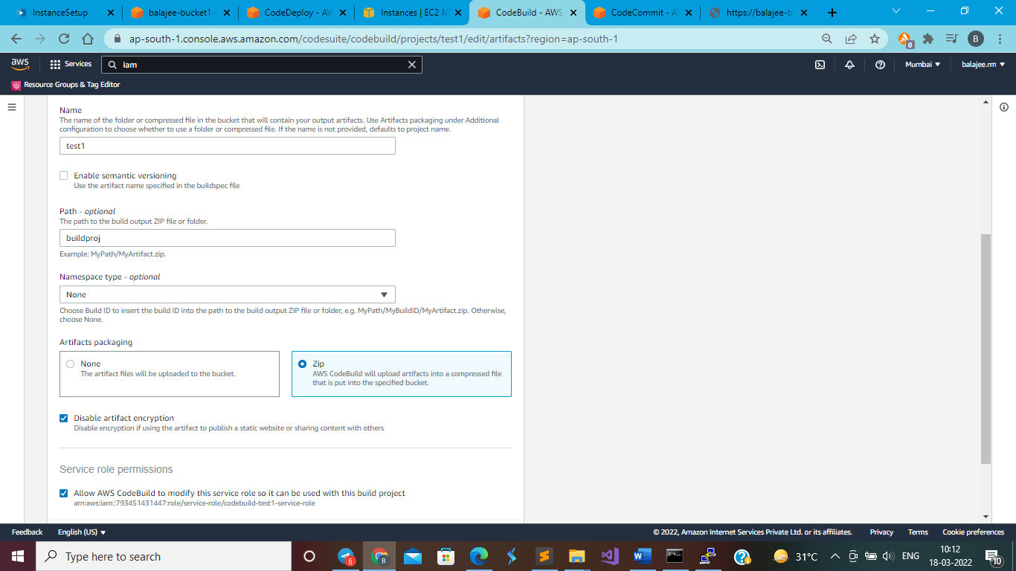

Click on create build and create it

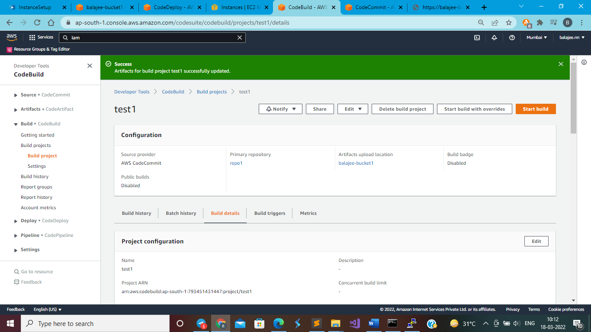

Click on start build

You will get build succeeded like this

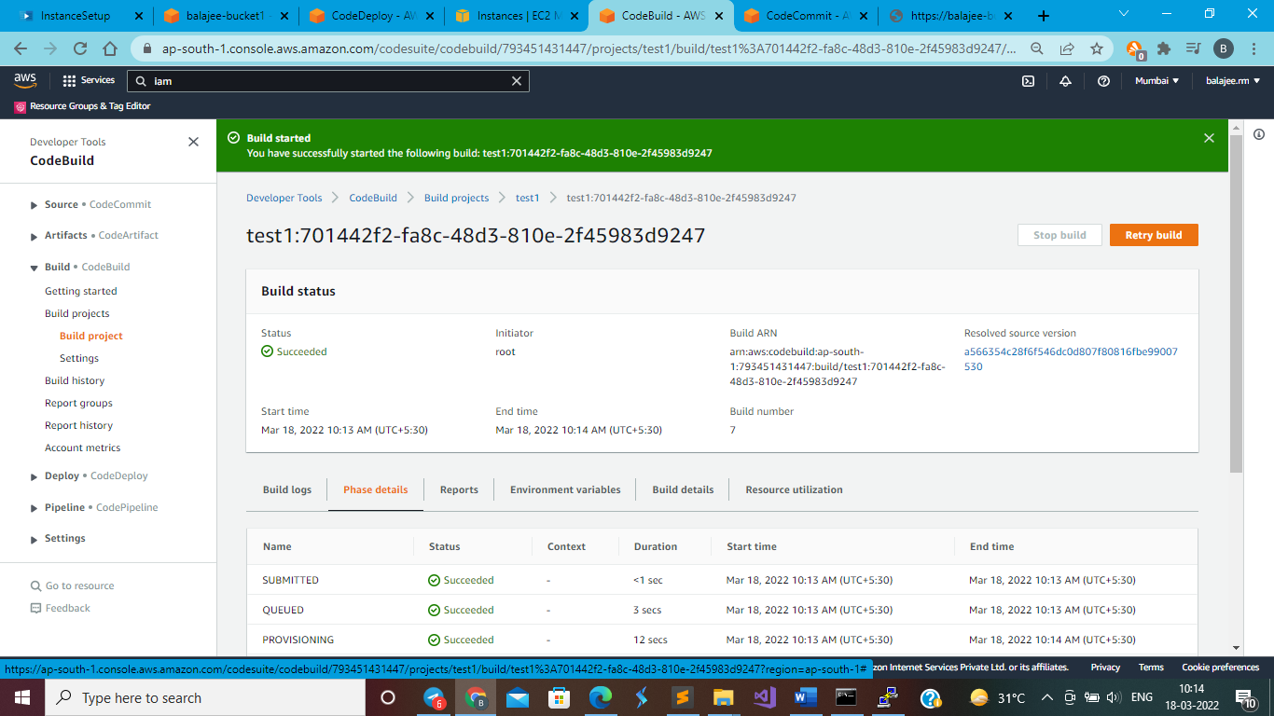

Note: it will use buildspec.yml file in repo for checking the condition, here we are just checking “welcome” word is present in index.html file or not.

After you are getting the zip file in bucket, make it as a public access and check whether it is downloadable by copy pasting the object url

**CodeDeploy**

Create one ec2 linux based in another tab and access it through putty terminal

Assign role for ec2 for s3 bucket access

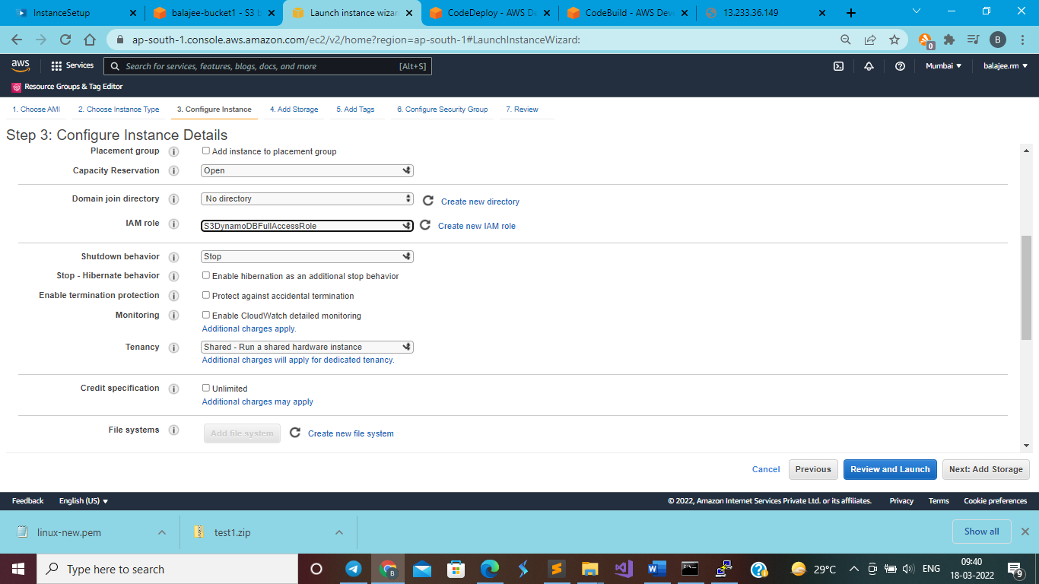

Provide the following 2 tags while creating ec2

* Name: M1
* Environment: product

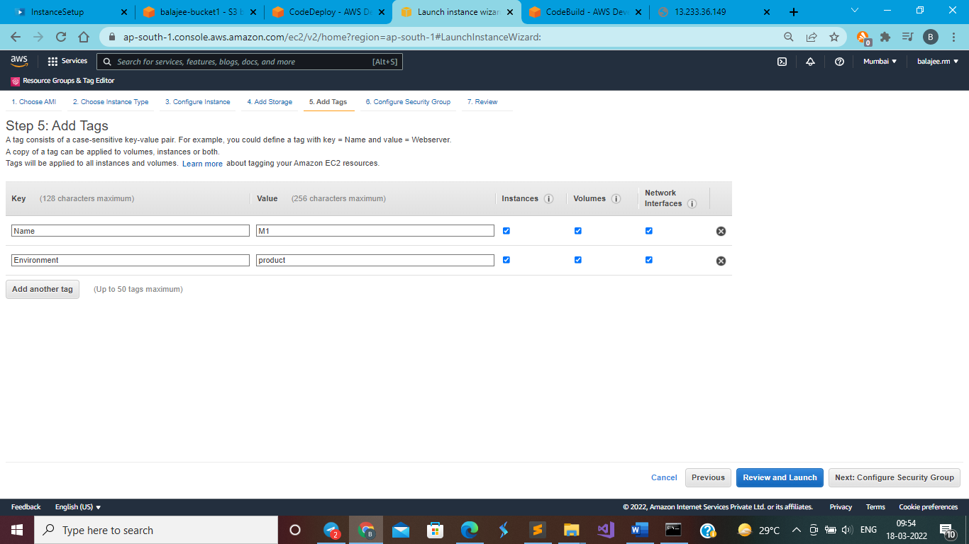

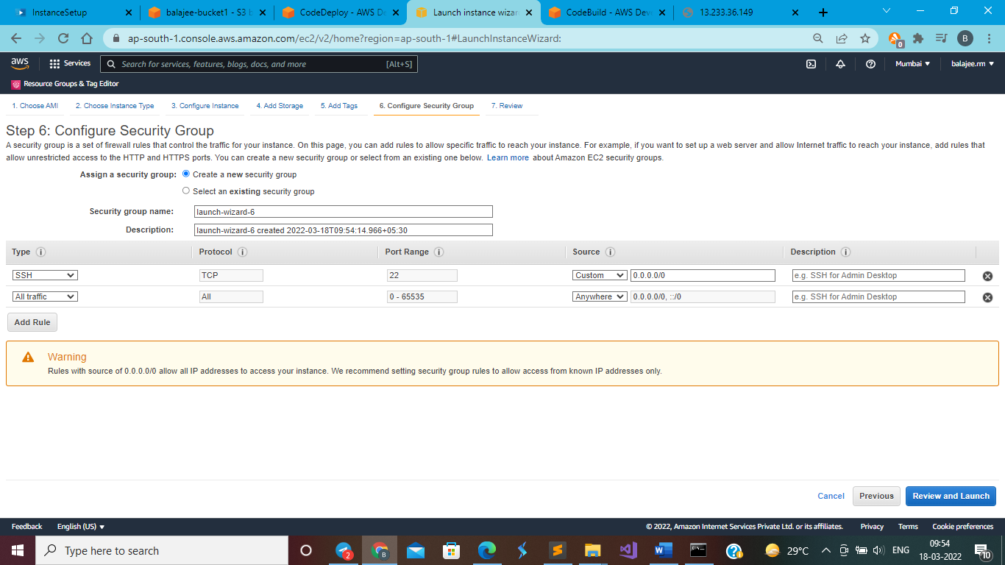

# Installing the CodeDeploy agent on EC2 terminal (putty terminal -> user name -> ec2-user)

sudo yum update -y

sudo yum install -y ruby wget

wget https://aws-codedeploy-eu-west-1.s3.eu-west-1.amazonaws.com/latest/install

chmod +x ./install

sudo ./install auto

sudo service codedeploy-agent status

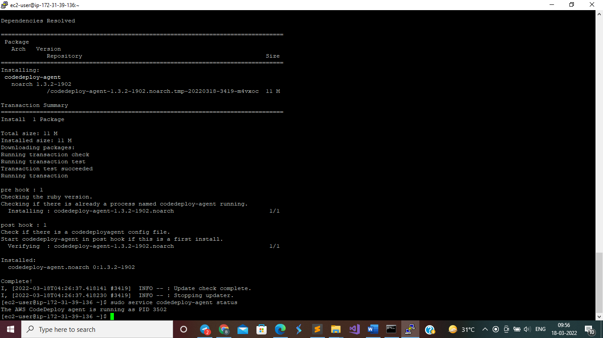

**After Installation**

Go to code deploy

Click on create application

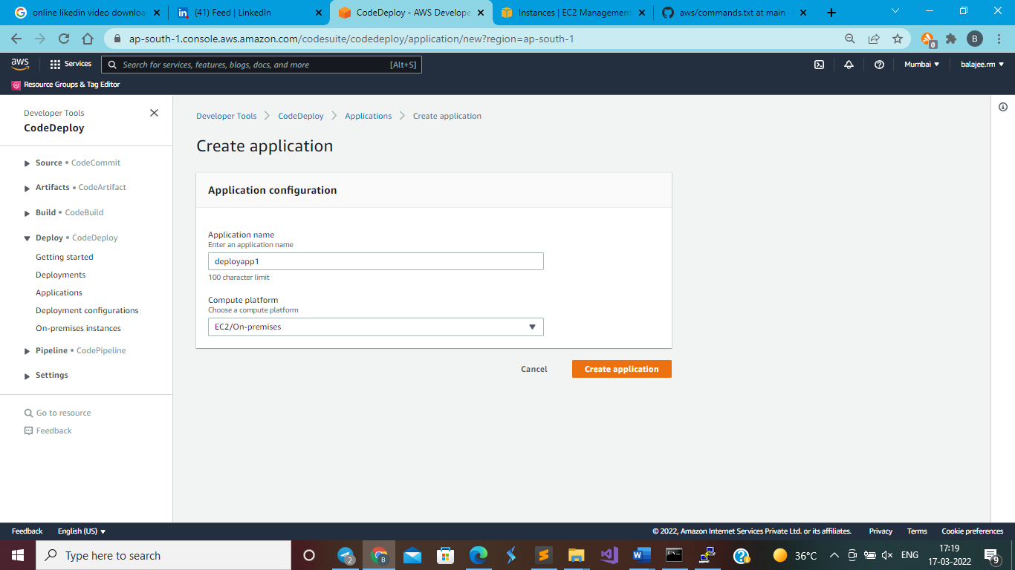

Create application

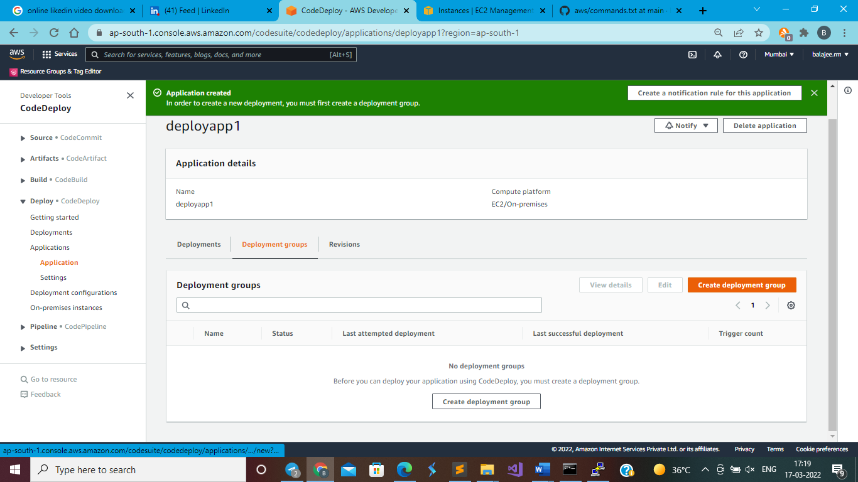

**Before clicking on create deployment group, first create IAM role for codedeploy**

The code deploy need to access the other services like created IAM Roles below

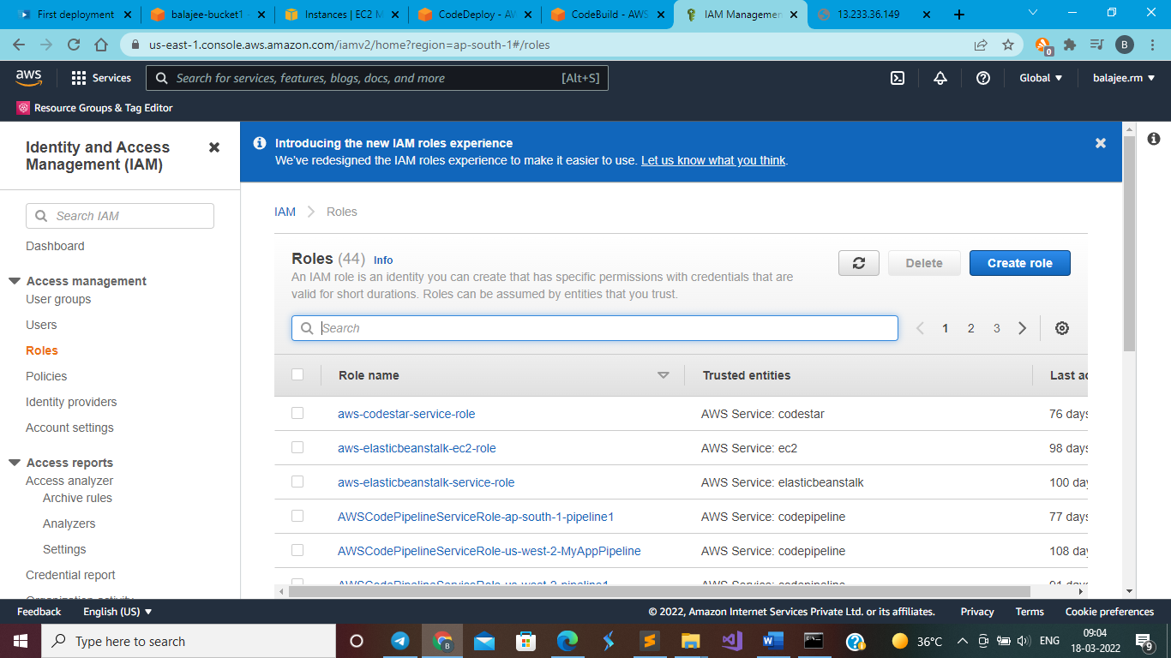

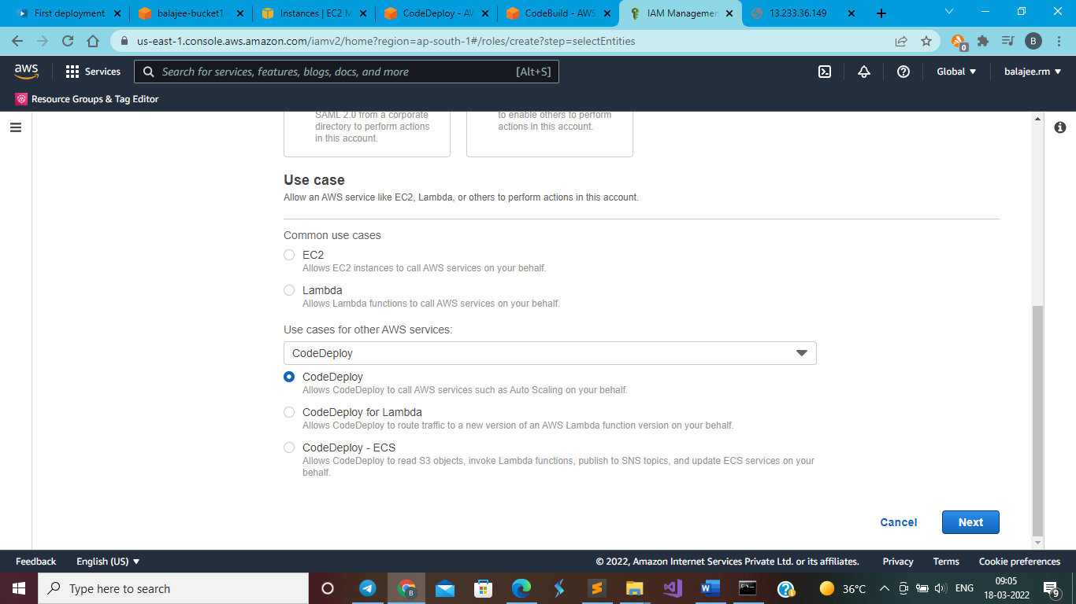

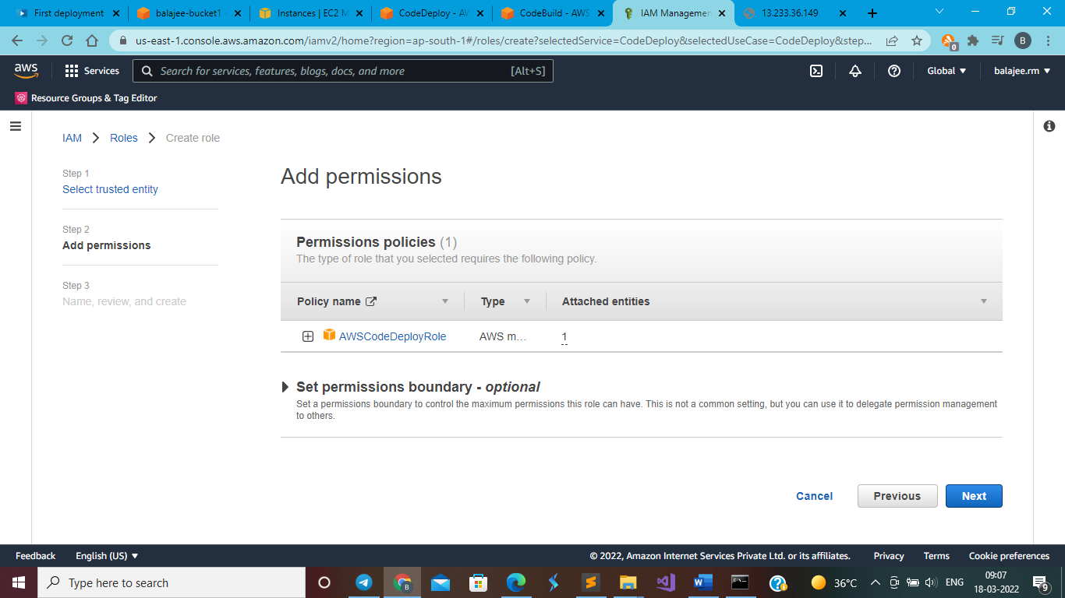

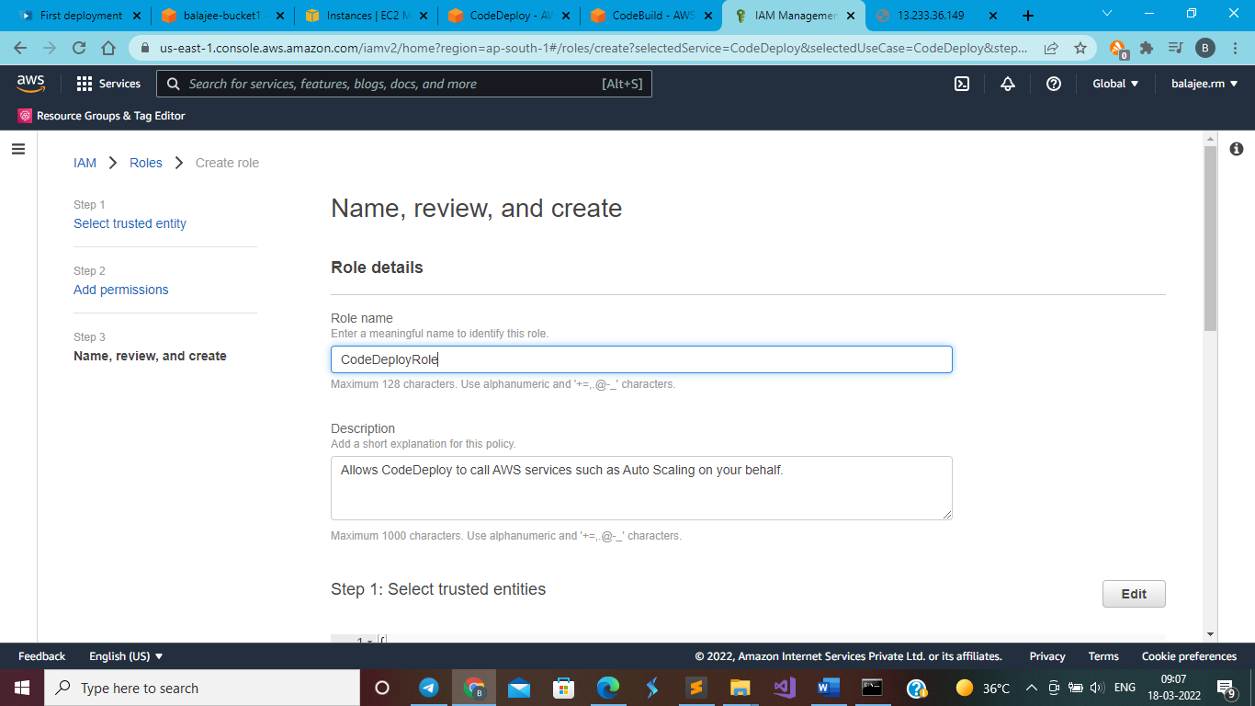

Again after creation modify the code deploy role for additional permissions as below

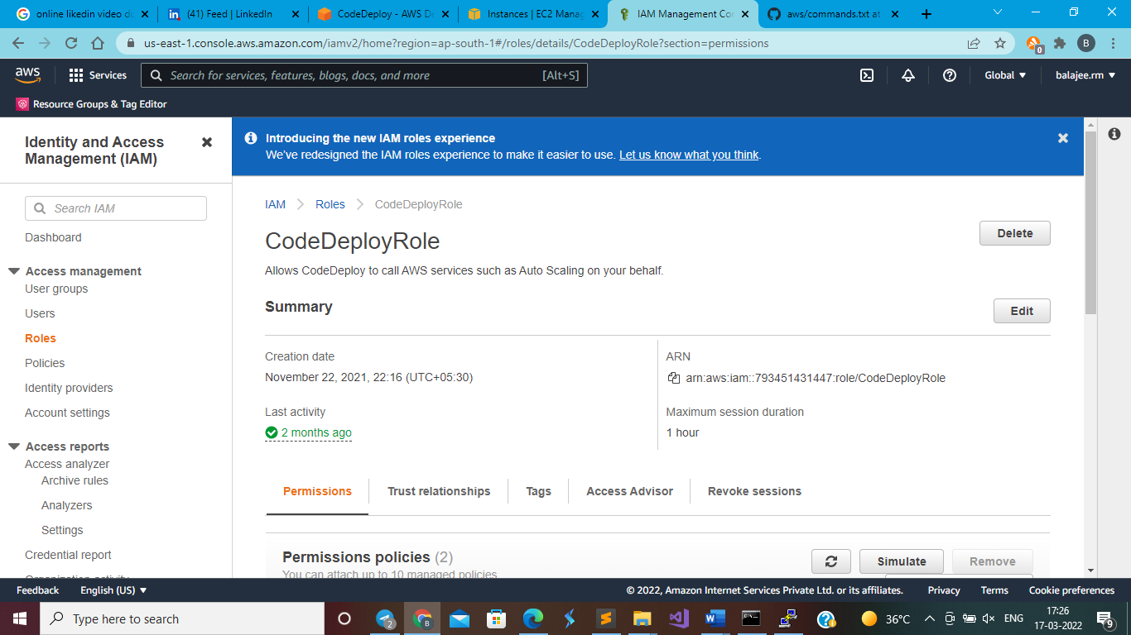

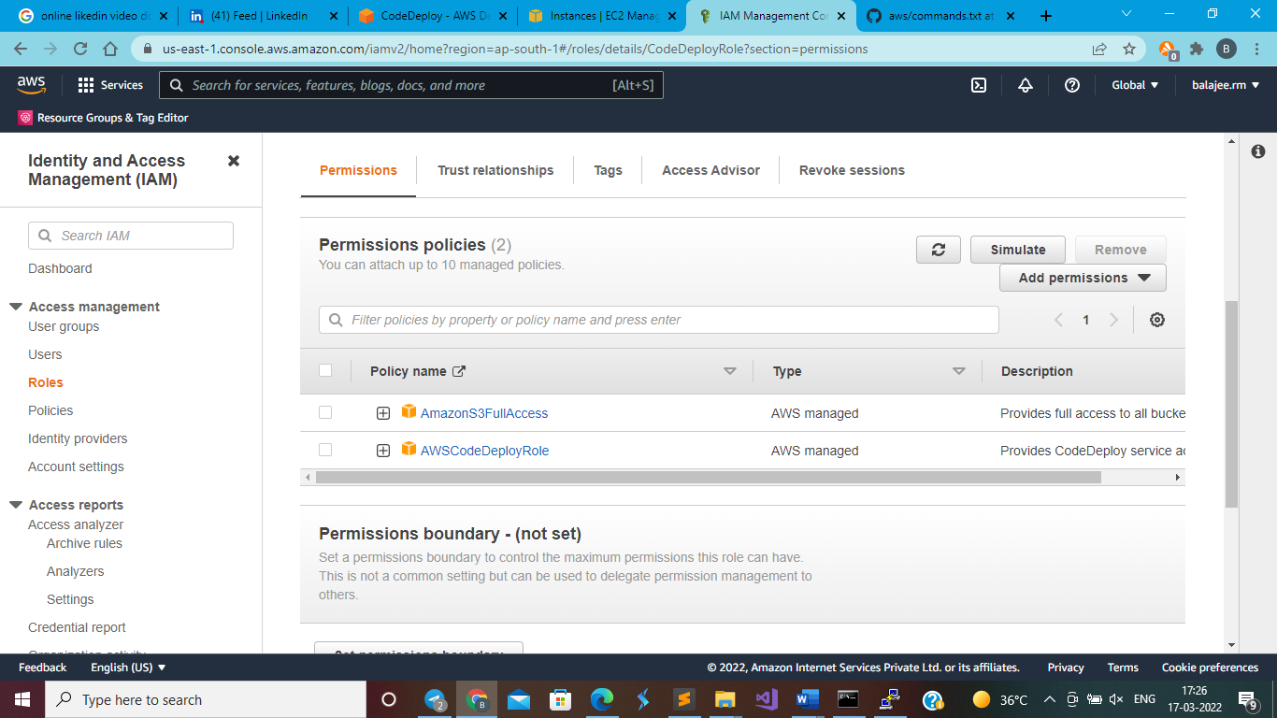

Now Create deployment group

Now assign the created role in deployment group creation

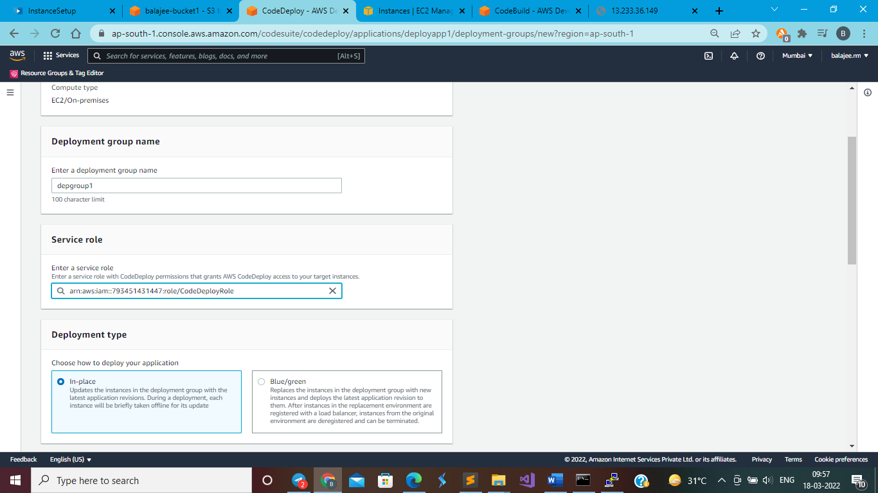

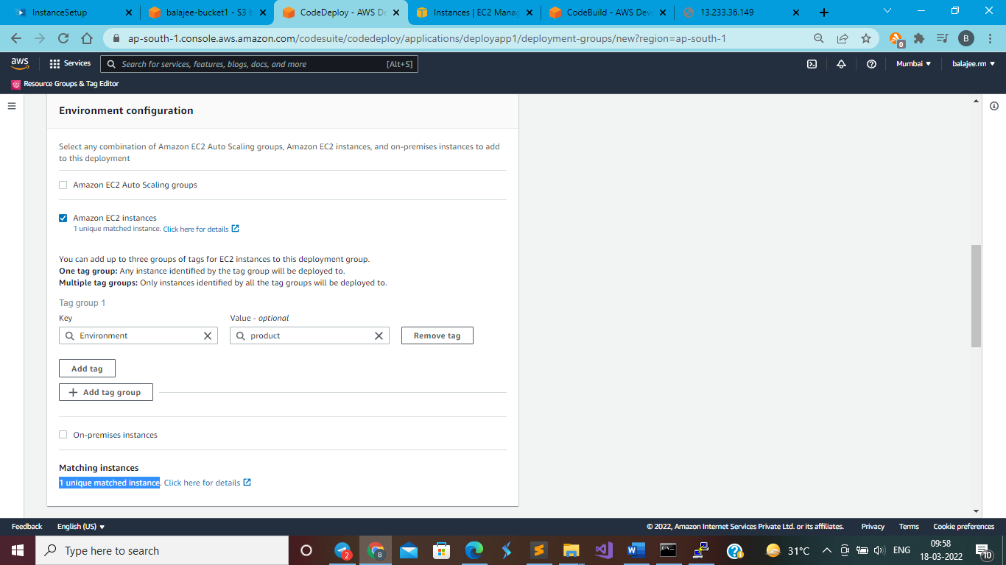

You should find 1 unique match as shown in the screen schot

Disable the load balances as below

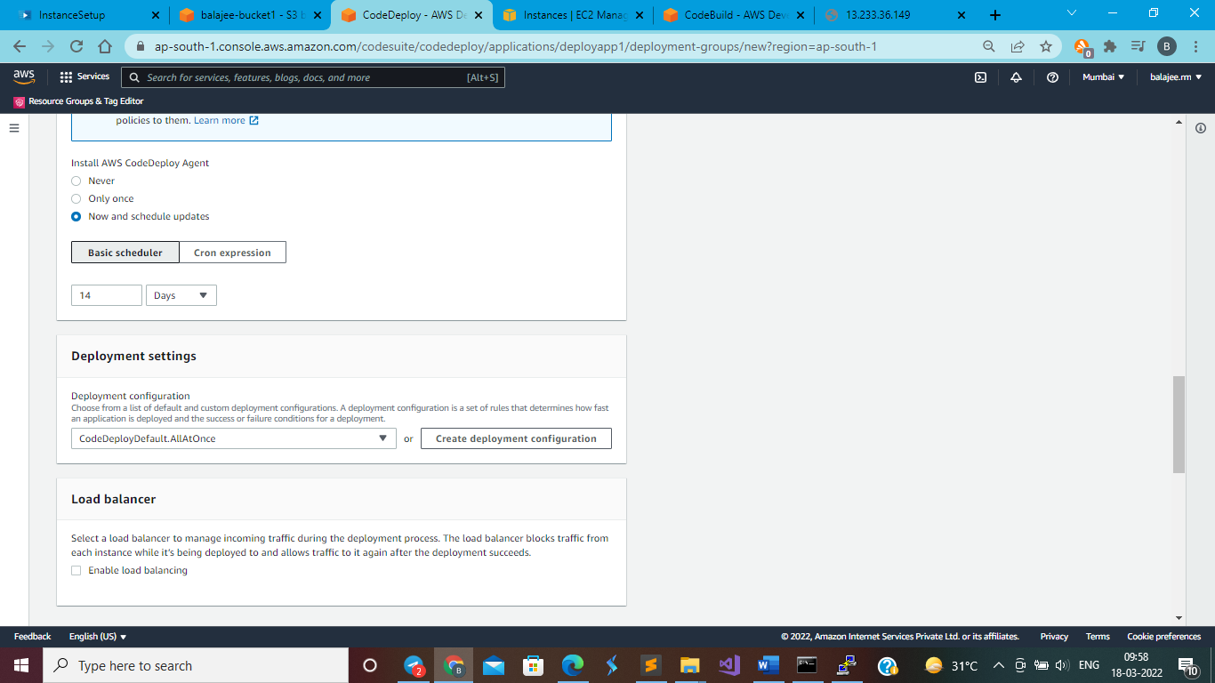

Enable roll back

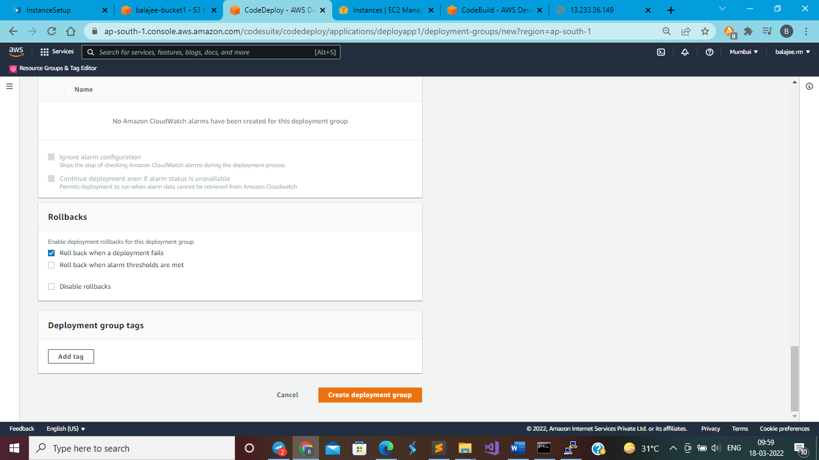

Click on create deployment

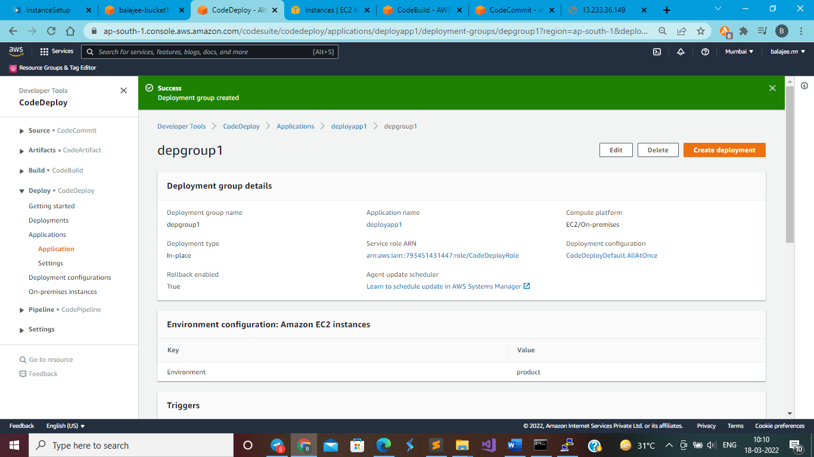

Click on create deployment

Open s3 bucket and get into the created folder to copy the object link and past it here as below

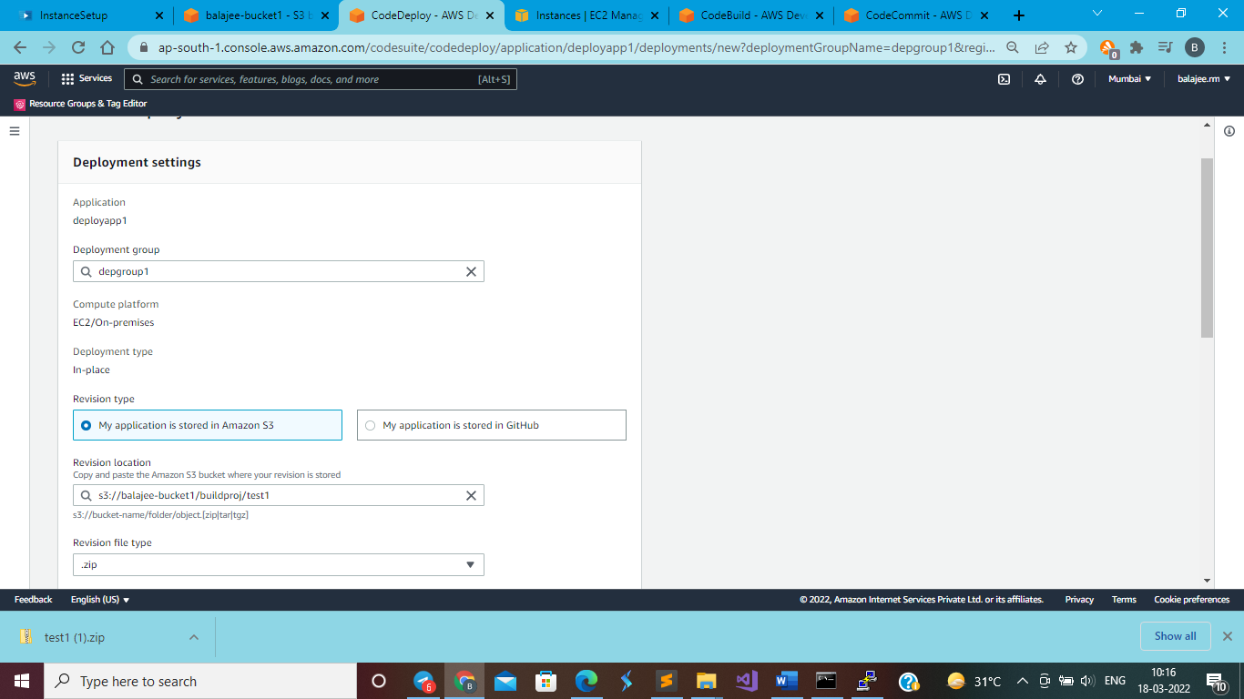

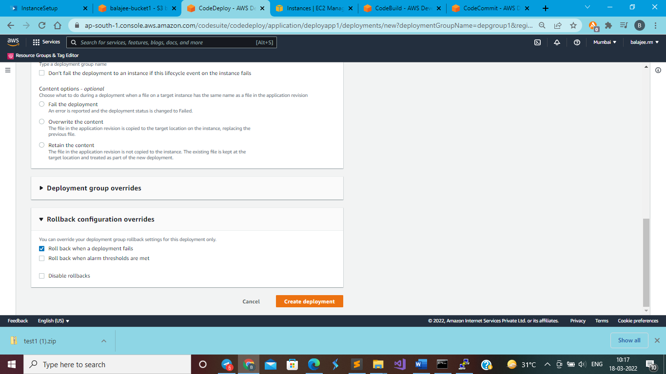

Click on create deployment

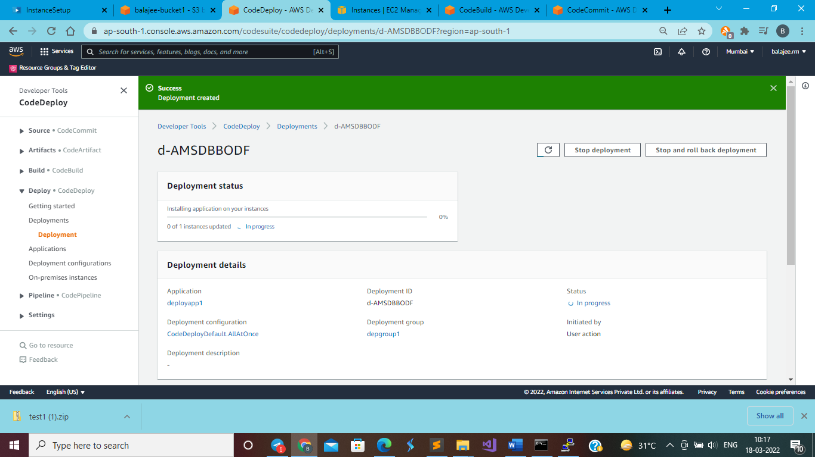

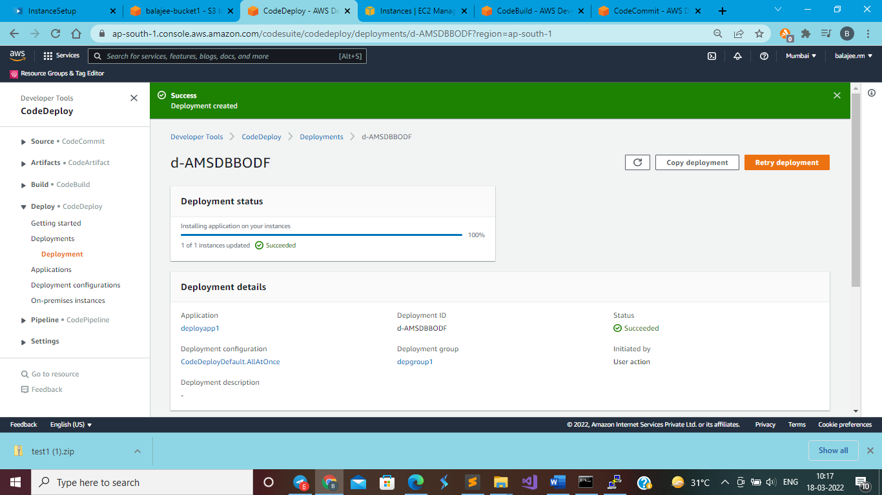

Go to ec2

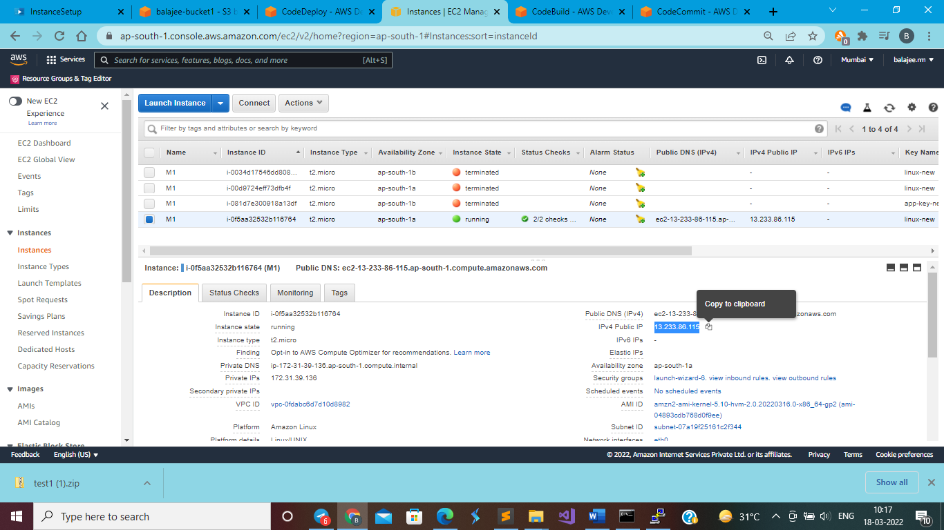

Copy public ip and past it in browser tab

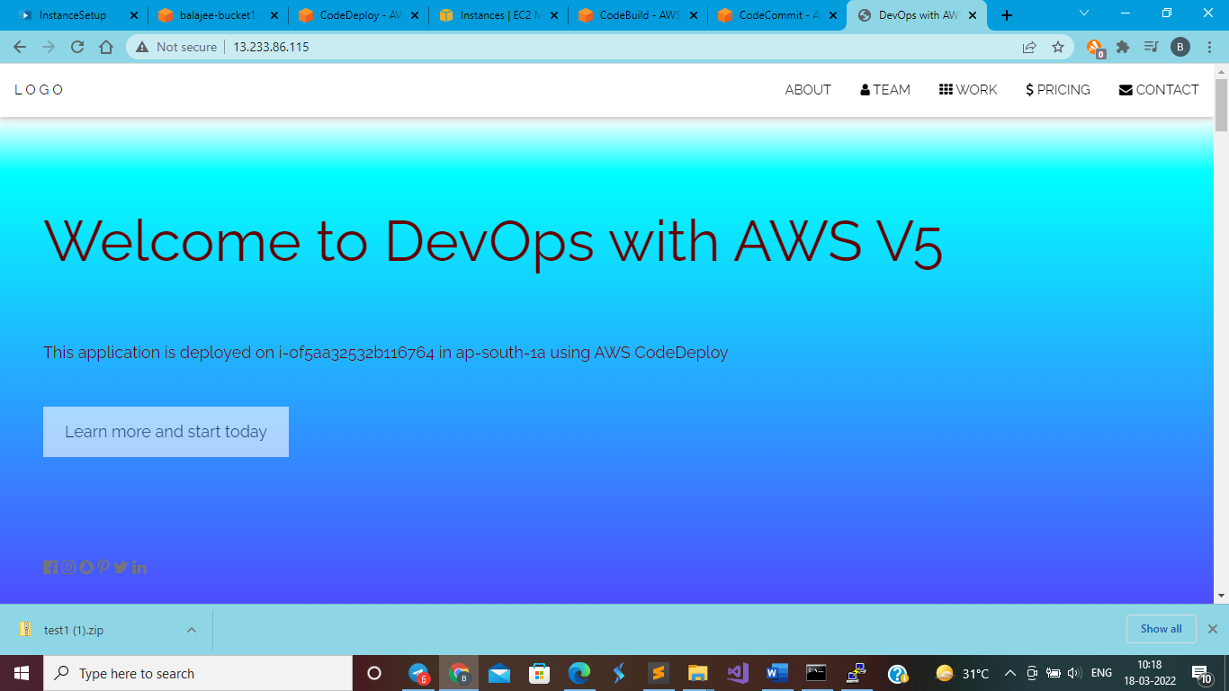

**AWS CodePipeline**

Go to codepipeline

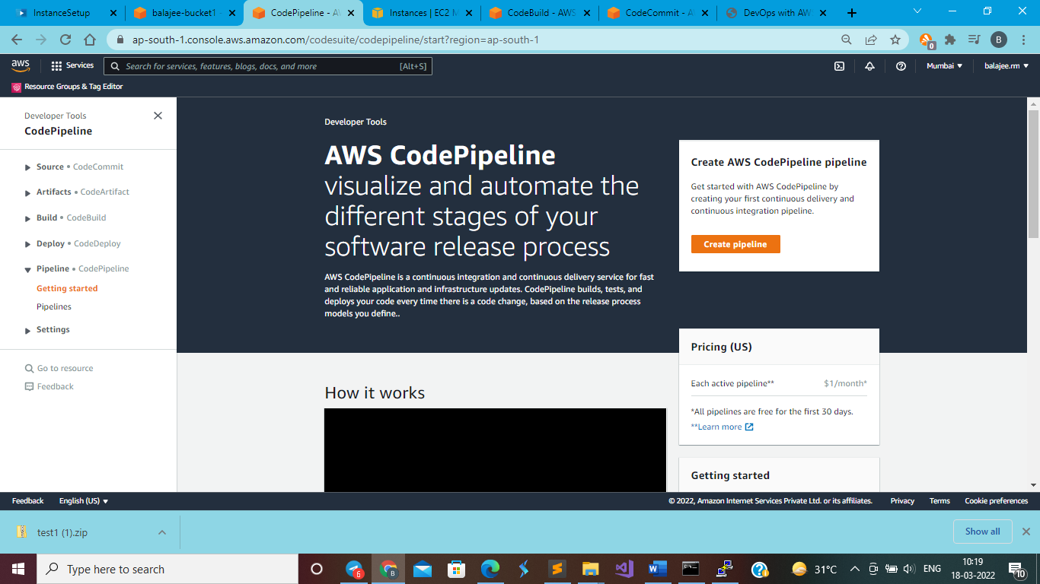

Click on create pipeline

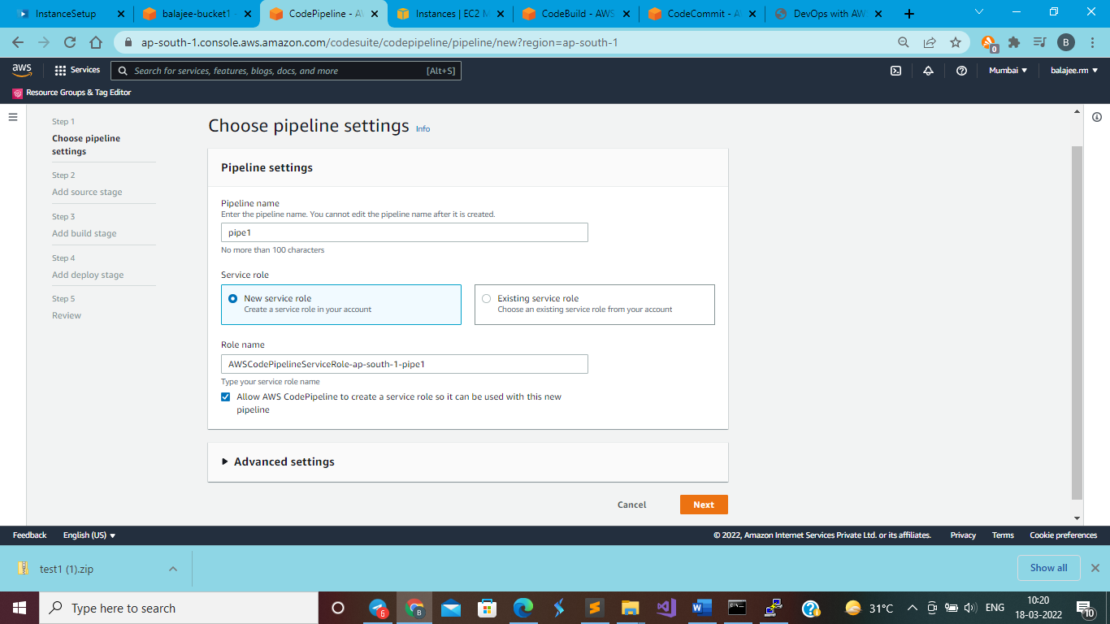

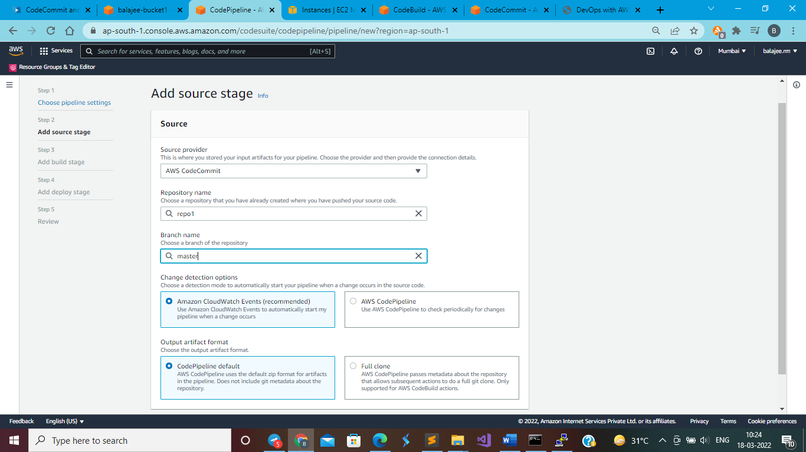

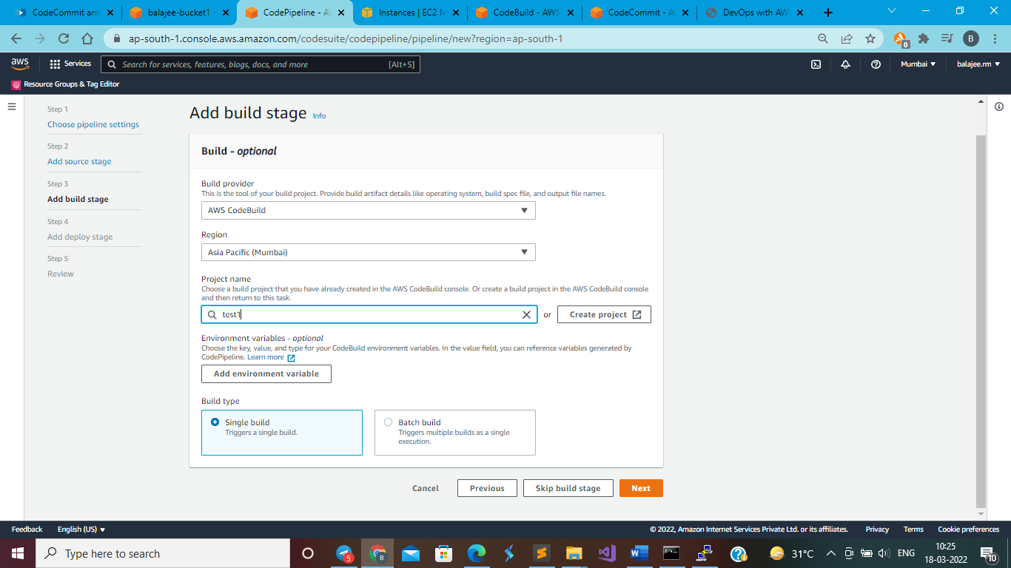

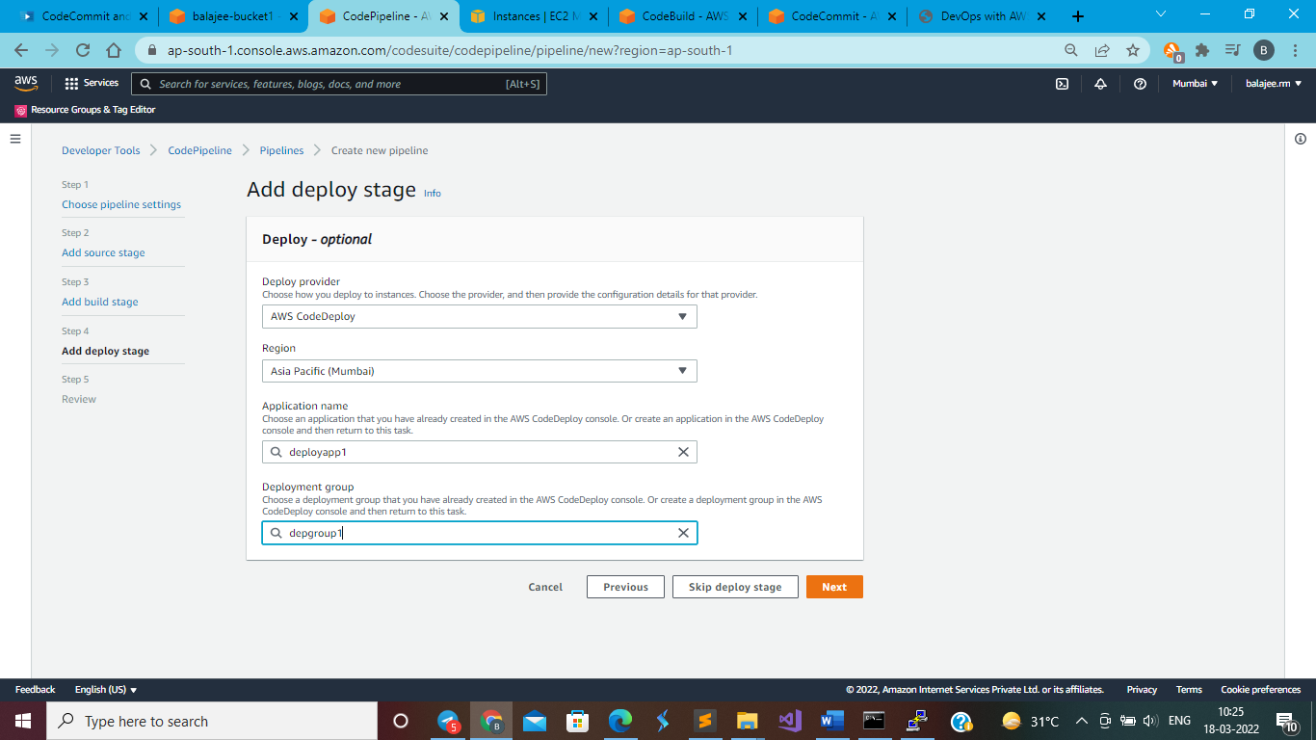

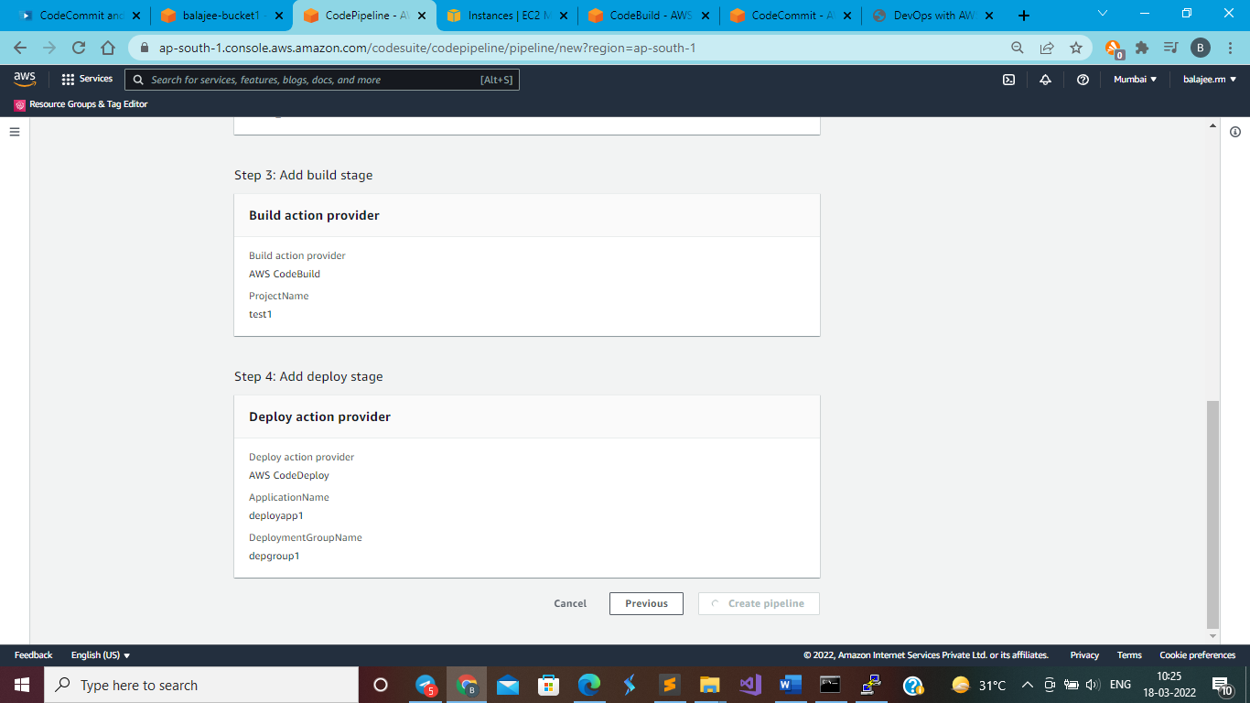

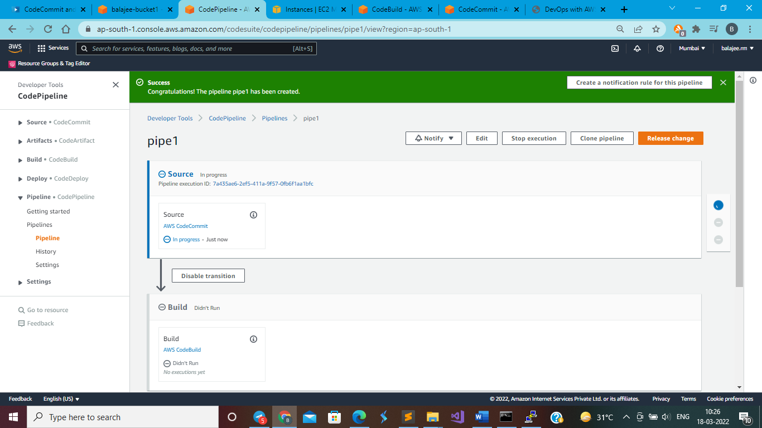

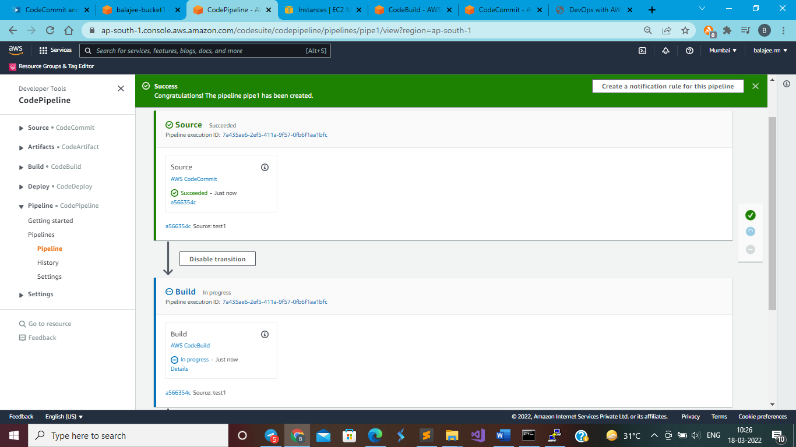

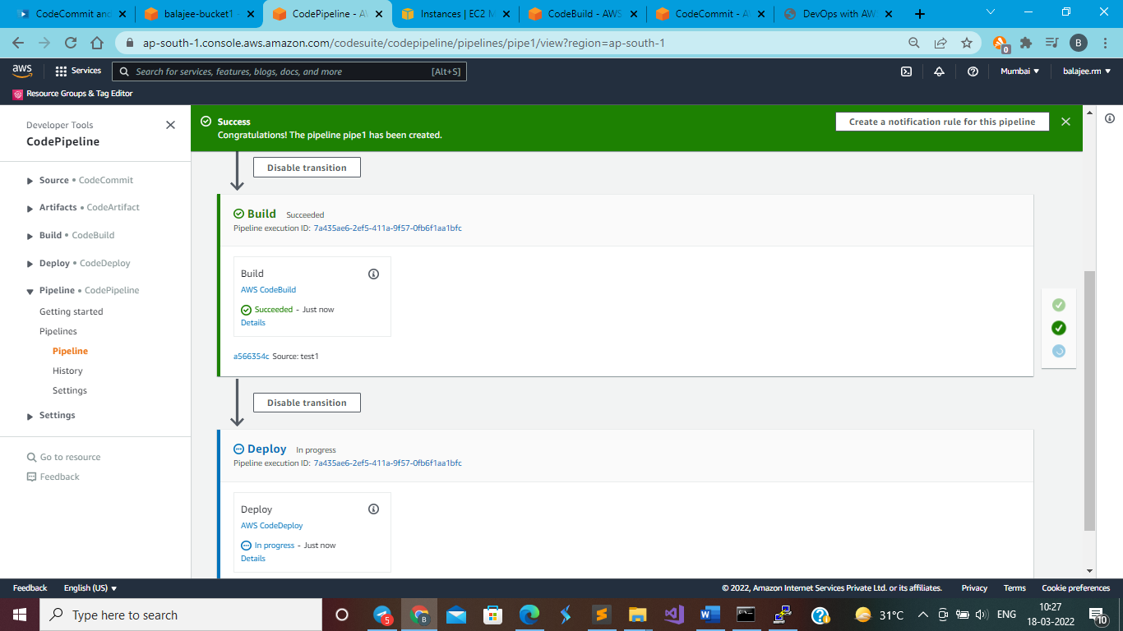

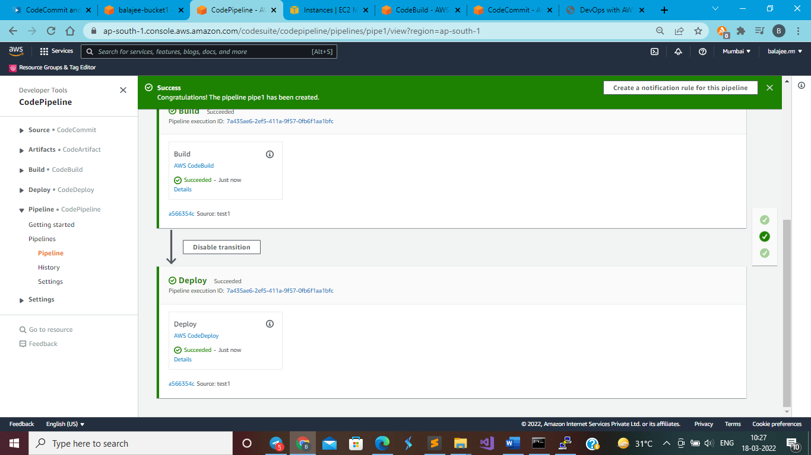

Now go to code commit and open index.html and modify any one line like “Welcome to DevOps with AWS V5” as “Welcome to DevOps with AWS Version 1”

Note: welcome word should be same or else you will get codebuild error

**AfterModification**

After modification, immediately, the codepipeline will do all the job by doing codecommit, codebuild and codedeploy.

